ACS- Affordable Cleaning Services
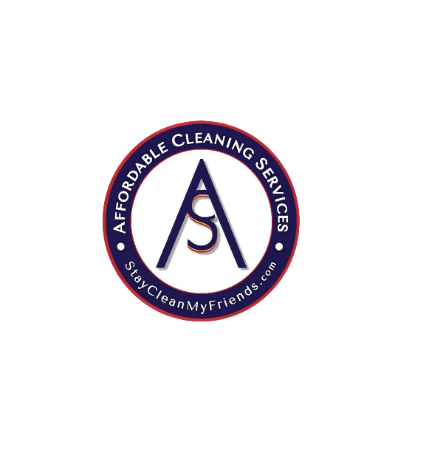

965 Spring Ridge Dr, Iowa City, IA 52246
319-471-3880

Employment Application
ACS- Affordable Cleaning Services is an equal opportunity employer. This application will not be used for limiting or excluding any applicant from consideration for employment on a basis prohibited by local, state, or federal law. Should an applicant need reasonable accommodation in the application process, he or she should contact a company representative.

Applicant Information
Full Name: |  |  |  |  |  | Date:
 | Last | First |  |  | M.I.
Address:
 | Street Address |  |  |  |  |  |  | Apartment/Unit #
 | City |  |  |  | State |  |  | ZIP Code
Phone: |  |  | Email

Date Available: |  | Social Security No.:

Are you a citizen of the United States? | YES | NO | If no, are you authorized to work in the U.S.? | YES | NO

Have you ever worked for this company? | YES | NO | If yes, when?

Do you have any friends, relatives, or acquaintances, working for ACS- Affordable Cleaning Services? | YES | NO | If yes, state name and relationship:
Are you 18 years of age or older? | YES | NO
Will you consent to a mandatory controlled substance test? | YES | NO

Have you ever been convicted of a criminal offense (felony or misdemeanor)? | YES | NO | If yes, please state the nature of the crime(s) when and where convicted and disposition of the case:  ______________________________________________
Do you have any condition that would require job accommodations? | YES | NO | If yes, please describe accommodation(s):

(Note: no applicant will be denied employment solely on the grounds of conviction of a criminal offense. The date of the offense, the nature of the offense, including any significant details that affect the description of the event and the surrounding circumstances and the relevance of the offense to the position(s) applied for may, however, be considered.)

Job Skills/Qualifications

Please list below the skills, qualifications, and certifications you possess for the position for which you are applying: ____________________________________________________________________________________________________________________________________________________________________________________________________________________________________________________________________________________________________________________________________________________________________________________________________________________________________________________________________________________________________________________
(Note: ACS- Affordable Cleaning Services complies with the ADA and considers reasonable accommodation measures that may be necessary for eligible applicants/employees to perform essential functions.)

Education
High School: |  |  |  |  |  |  | Address:
From: |  |  |  | To: |  | Did you graduate? |  | YES | NO | Diploma:
College: |  |  |  |  |  |  | Address:
From: |  |  |  | To: |  | Did you graduate? |  | YES | NO | Degree:
Other: |  |  |  |  |  |  | Address: | _____________________________________________
From: |  |  |  | To: |  | Did you graduate? |  | YES | NO | Degree:

References
Please list two professional references.
Full Name: |  | Relationship:
Company: |  | Phone:
Address:
Full Name: |  | Relationship:
Company: |  | Phone:
Address:

Previous Employment
Company: | Check HERE if you have no work history | Phone:
Address: |  | Supervisor:

Job Title: |  |  |  |  |  | Starting Salary: |  |  | $ |  | Ending Salary: |  | $
Responsibilities:
From: |  |  |  | To: |  |  | Reason for Leaving:
May we contact your previous supervisor for a reference? |  |  |  |  |  |  |  | YES |  | NO
Company: |  |  |  |  |  |  |  |  |  |  | Phone:
Address: |  |  |  |  |  |  |  |  |  |  | Supervisor:

Job Title: |  |  |  |  |  | Starting Salary: |  |  | $ |  | Ending Salary: |  | $
Responsibilities:
From: |  |  |  | To: |  |  | Reason for Leaving:
May we contact your previous supervisor for a reference? |  |  |  |  |  |  |  | YES |  | NO
Company: |  |  |  |  |  |  |  |  |  |  | Phone:
Address: |  |  |  |  |  |  |  |  |  |  | Supervisor:

Job Title: |  |  |  |  |  | Starting Salary: |  |  | $ |  | Ending Salary: | $
Responsibilities:
From: |  |  |  | To: |  |  | Reason for Leaving:
May we contact your previous supervisor for a reference? |  |  |  |  |  |  |  | YES |  | NO

Employment Position and Availability

How did you hear about this position? __________________________________________________________
What days of the week are you available for work (Check all days that apply- leave days unavailable BLANK):

Mon: ___Tues: ___ Weds: ___Thurs: ___ Fri: ___ Sat: ___ Sun: ___

What hours/shifts are you available for work? ____________________________________________________________
_________________________________________________________________________________________________
Full time or Part time? ______________________________________________________________________________
What date are you available to start? ___________________________________________________________________
Are you available for “on-call” work? ___________________________________________________________________
Do you have reliable transportation to and from work? ___________________________________________________
Salary desired? _______________________________________

Disclaimer and Signature
The relationship between you and ACS- Affordable Cleaning Services is referred to as “employment at will”. This means that your employment can be terminated at any time for any reason with or without cause, with or without notice, by your ACS- Affordable Cleaning services. No representative of ACS- Affordable Cleaning Services has authority to enter into any agreement contrary to the foregoing “employment at will” relationship. You understand that your employment is “at will” and that you acknowledge that no oral or written statements or representations regarding your employment can alter your at- will employment status, except for a written statement signed by you and either our Executive Vice-President/Chief Operations Officer or the Company’s President.
I certify that my answers are true and complete to the best of my knowledge.
If this application leads to employment, I understand that false or misleading information in my application or interview may result in my release.
Signature: |  | Date:

